Using Spyder Editor :

.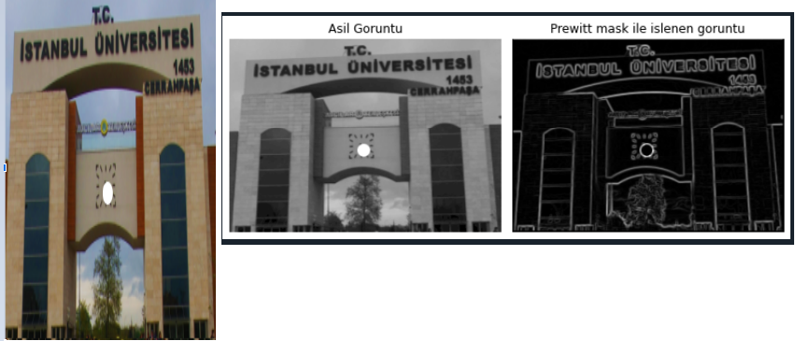

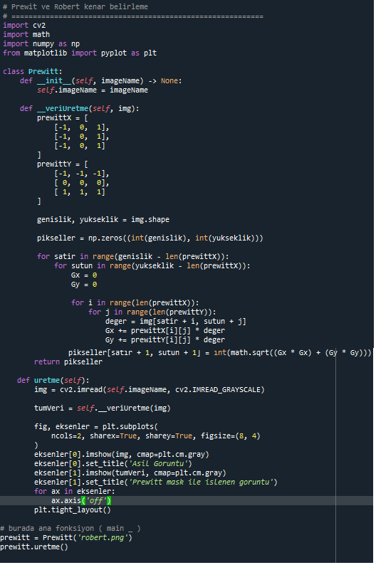

# # AD : Mueyyed Garzuddin

# # NO : 1306180132

# # Tarih : 2022.04.18

# ===========================================================

# Prewit belirleme

# ===========================================================

import cv2

import math

import numpy as np

from matplotlib import pyplot as plt

class Prewitt:

def __init__(self, imageName) -> None:

self.imageName = imageName

def __veriUretme(self, img):

prewittX = [

[-1, 0, 1],

[-1, 0, 1],

[-1, 0, 1]

]

prewittY = [

[-1, -1, -1],

[ 0, 0, 0],

[ 1, 1, 1]

]

genislik, yukseklik = img.shape

pikseller = np.zeros((int(genislik), int(yukseklik)))

for satir in range(genislik - len(prewittX)):

for sutun in range(yukseklik - len(prewittX)):

Gx = 0

Gy = 0

for i in range(len(prewittX)):

for j in range(len(prewittY)):

deger = img[satir + i, sutun + j]

Gx += prewittX[i][j] * deger

Gy += prewittY[i][j] * deger

pikseller[satir + 1, sutun + 1] = int(math.sqrt((Gx * Gx) + (Gy * Gy)))

return pikseller

def uretme(self):

img = cv2.imread(self.imageName, cv2.IMREAD_GRAYSCALE)

tumVeri = self.__veriUretme(img)

fig, eksenler = plt.subplots(

ncols=2, sharex=True, sharey=True, figsize=(8, 4)

)

eksenler[0].imshow(img, cmap=plt.cm.gray)

eksenler[0].set_title('Asil Goruntu')

eksenler[1].imshow(tumVeri, cmap=plt.cm.gray)

eksenler[1].set_title('Prewitt mask ile islenen goruntu')

for ax in eksenler:

ax.axis('off')

plt.tight_layout()

# burada ana fonksiyon ( main _ )

prewitt = Prewitt('robert.png')

prewitt.uretme()